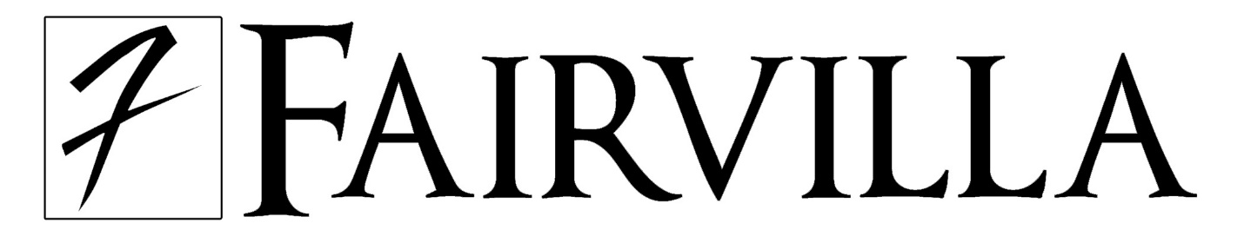
Club F Emerald Membership Application
- I wish to join and receive emailed information on upcoming events & special offers.
- I wish to join and not receive emailed information on upcoming events & special offers.
Membership #
ALL INFORMATION MUST BE COMPLETED FOR ACCEPTANCE - PLEASE PRINT CLEARLY
Club F Rewards Program Membership:
NAME (First) ______________________ (Last) __________________________
EMAIL _________________________________
ZIPCODE ___________________
DATE OF BIRTH ________________

Signature required only if member wishes to utilize the RENATL OPTION

CLUB F RENTAL OPTION: (this is a membership option, available exclusively at Fairvilla Megastore located at 1740 N Orange Blossom Trail location and is optional to participate)
Applicant acknowledges that they have received and read a copy of all current Fairvilla Megastore Terms and Conditions for the CLUB F RENTAL OPTION and agree that membership card(s) issued by Fairvilla will be used only as provided in such Terms and Conditions. Fairvilla reserves the right, at any time and without notice, to amend the Terms and Conditions of Membership. APPLICANT ACKNOWLEDGES AND ACCEPTS FULL RESPONSIBILITY AND GUARANTEES PAYMENT FOR ALL ITEMS RENTED THROUGH THE USE OF THE CLUB F RENTAL OPTION ON THEIR ACCOUNT, WHETHER OR NOT SUCH USE IS AUTHORIZED BY APPLICANT. Applicant agrees that Fairvilla may pursue all avenues of collection, including use of collection agencies, to recover all charges and all other unpaid amounts due to (a) Applicant’s failure to timely return all items rented through the use of the CLUB F RENTAL OPTION, (b) damages to returned items (not to exceed the retail price of the item), and (c) other unpaid charges and reasonable legal fees resulting from the failure to return rented items. Applicant also understands that they must notify Fairvilla immediately in the event of any info changes.
Membership will be revoked with or without cause and action taken if false information is provided at any time.

CLUB F RENTAL: TERMS AND CONDITIONS
1. Member must notify Fairvilla Megastore immediately in person, by telephone or in writing if their membership card is lost or stolen. Member is responsible for all use of the card prior to receipt by Fairvilla of notice of the loss or theft of the card.
2. Failure to notify the issuing store of the loss or theft of your membership card may result in the posting of significant charges to the credit card account, which you identify on the application.
3. Any rented item not returned to the proper Fairvilla Megastore within twenty (20) days after rental may, at the option of Fairvilla Megastore, be converted from a rental to a sale. Member is responsible for the full retail price of the unreturned item plus all rental and extended viewing fees and other related charges arising from the rental prior to conversion to a sale.
4. Customer information is kept confidential & maintained by Fairvilla Megastore & not sold distributed to any outside parties. Member authorizes Fairvilla Megastore to release information contained in the application or generated by or through the use of the membership (a) for account maintenance purposes and (b) to Fairvilla Megastore’s franchises for use in the ordinary course of their business including debt collection and marketing purposes.
5. Member acknowledges that videos must be returned by 2AM the evening they are due to avoid extended viewing fees which shall be assessed on a daily basis. Member may ask store personnel for further explanation.
6. Member is responsible for returning rental items to Fairvilla Megastore 1740 North Orange Blossom Trail, Orlando, FL 32804.

ADDRESS (No PO Boxes)

_______________________________________________________________________________

CITY__________________________________ STATE _______________ TELEPHONE ________________

Applicant Signature______________________________________________ Date _____________

